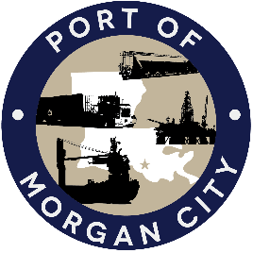

NOTICE OF PUBLIC MEETING

MORGAN CITY HARBOR AND TERMINAL DISTRICT

Notice is given that a special meeting of the Board of Commissioners of the Morgan City Harbor and Terminal District (“District”) has been called by Duane Lodrigue, President of the Board of Commissioners, and will be held at 7327 Highway 182, Morgan City, Louisiana on Thursday, December 21, 2017 at 4:30 p.m. for the following purposes and to take appropriate action thereon, to wit:

AGENDA

- Call to Order

- Roll Call

- Discussion and any action on December 19, 2017 email from U.S. Army Corps of Engineers on contribution of funds by District to Corps for extension of dredging operations by dredge Borenquin

- Discussion and any action on Atchafalaya River Channel including dredging and sediment management, equipment purchases, reports, survey services, consulting services, economic study(ies), cooperative agreements with Brice Civil Contractors and the U.S. Army Corps of Engineers

- Adjournment

Morgan City Harbor and Terminal District
/s/ Duane E. Lodrigue, President

In accordance with the Americans with Disabilities Act, if you need special assistance, please contact Tori Henry at 985-384-0850, describing the assistance that is necessary.

